**Gitlab and Rancher deployment - CI-CD and pipelines**

[](https://rancher.com/)[](https://gitlab.com/)

Table des matières

I. Introduction 2

II. Gitlab repo and config 2

III. Gitlab-runner 4

1. Runner on Docker 5

a. Prerequisites 5

b. Install the service "gitlab-runner" on Docker 5

c. Configure the service "gitlab-runner" on Docker 5

2. Runner on Debian (not tested and obsolete) 6

a. Prerequisites 6

b. Install the service "gitlab-runner" on Debian 6

c. Configure the service "gitlab-runner" on Debian 6

IV. File gitlab-ci.yml 7

1. First file gitlab-ci.yml 7

2. Advanced file gitlab-ci.yml 8

V. Deploy in production 9

1. Build the environment 9

a. File HTML 9

b. File .gitlab-ci.yml 9

2. Test the code 10

a. File .gitlab-ci.yml 10

3. Create the Docker image and push into Gitlab registry 11

a. File docker-compose.yml 11

b. File Dockerfile 11

c. File .gitlab-ci.yml 12

4. Deploy in production 13

a. Manually 13

b. Automatically with Rancher 14

# Introduction

The goal is to automatist the integration of the code.

* Source:

# Gitlab repo and config

* 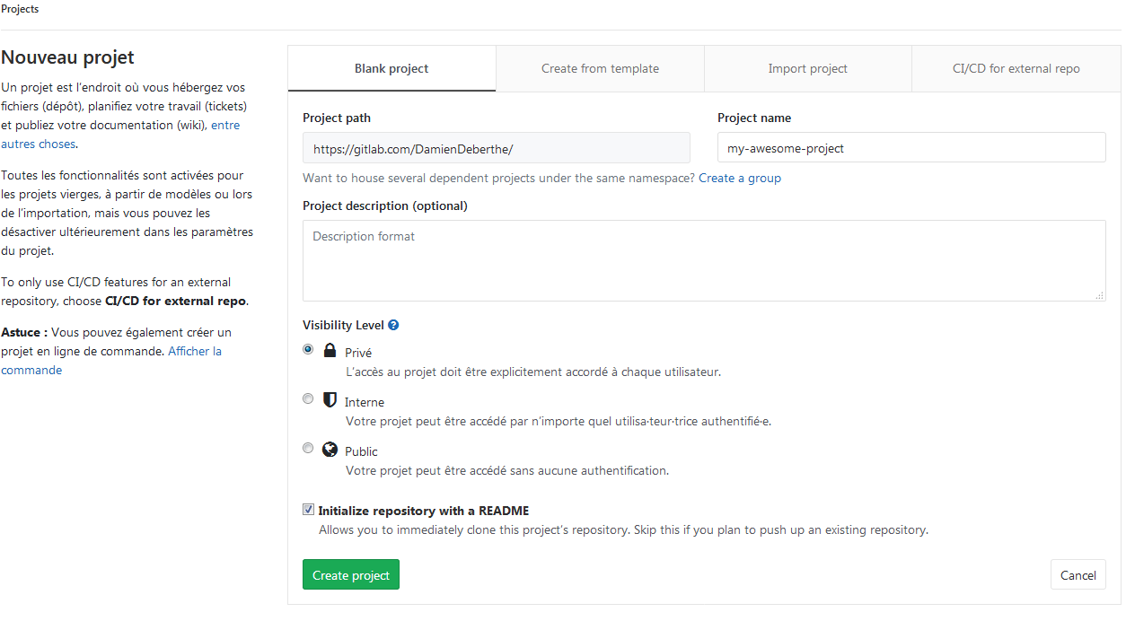Create new project:
* The CI/CD information are these 2 menus:

For integration For configuration

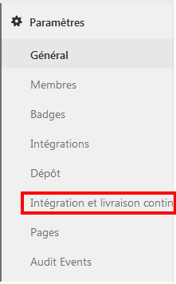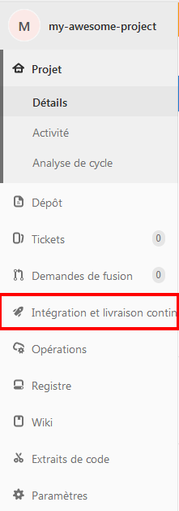

You can find this link for explications: <https://gitlab.com/help/ci/quick_start/README>

# Gitlab-runner

The Gitlab-runner is an element that run the jobs that you define in “.gitlab-ci.yml”.

At the beginning, Gitlab give us free runners from Digital Ocean and it’s automatic and transparent. But it’s very slow (between 1 to 3 min for each task). Better solution is to install our Runner.

* Source : <https://gitlab.com/help/ci/runners/README.md>

<https://docs.gitlab.com/runner/>

Let’s do this!

## Runner on Docker

### Prerequisites

Install sudo, curl, docker: (*Why docker?* Because runner will launch Docker image for test and verify pipelines)

|  |
| --- |
| apt-get update && apt-get install -y sudo curl  curl -L https://raw.githubusercontent.com/DamienDeberthe/Documentations/master/Docker/Scripts/docker-install-auto.sh | bash |

### Install the service "gitlab-runner" on Docker

Create the docker for the runner:

|  |
| --- |
| docker run -d --name gitlab-runner --restart always -v /var/run/docker.sock:/var/run/docker.sock -v /data/gitlab-runner:/etc/gitlab-runner gitlab/gitlab-runner:latest |

### Configure the service "gitlab-runner" on Docker

Execute these commands to connect the docker runner with the project on Gitlab:

docker exec -it gitlab-runner gitlab-runner register

Response like:

|  |
| --- |
| Please enter the gitlab-ci coordinator URL (e.g. https://gitlab.com/):  https://gitlab.com  Please enter the gitlab-ci token for this runner:  xxx  Please enter the gitlab-ci description for this runner:  [b3fec93a1a72]: runner-for-this-awesome-project  Please enter the gitlab-ci tags for this runner (comma separated):  Registering runner... succeeded runner=xxx  Please enter the executor: docker, virtualbox, docker-ssh+machine, docker+machine, kubernetes, docker-ssh, parallels, shell, ssh:  docker  Please enter the default Docker image (e.g. ruby:2.1):  ruby:2.1  Runner registered successfully. Feel free to start it, but if it's running already the config should be automatically reloaded! |

You can find the configuration in the file “/data/gitlab-runner/config.toml”

🡪 To see the runners: Gitlab project -> Paramètre -> Intégration et livraison continue -> Exécuteurs: Runners activated for this project

It’s better to disable the shared runners for increase speed. 

* Source: <https://www.sheevaboite.fr/articles/installer-gitlab-ci-moins-5-minutes-docker/>

## Runner on Debian (not tested and obsolete)

### Prerequisites

Install sudo, curl:

apt-get update && apt-get install -y sudo curl

### Install the service "gitlab-runner" on Debian

|  |
| --- |
| curl -L https://packages.gitlab.com/install/repositories/runner/gitlab-runner/script.deb.sh | sudo bash  apt-get install gitlab-runner |

* Source : <https://docs.gitlab.com/runner/install/linux-repository.html>

### Configure the service "gitlab-runner" on Debian

On the server runner, execute these commands to connect the runner with the project on Gitlab:

|  |
| --- |
| gitlab-runner register  https://gitlab.com  token : find on the Gitlab project -> Paramètre -> Intégration et livraison continue -> Pipelines généraux : Jeton de l'exécuteur  <name_of_this_runner>  <tag>  Bash? Docker? |

The configuration is in the file: ~/.gitlab-runner/config.toml

Start the service:

service gitlab-runner start

For active runner and can hosted pipelines:

gitlab-runner run

🡪 To see the runners: Gitlab project -> Paramètre -> Intégration et livraison continue -> Exécuteurs: Runners activated for this project

* Sources: <https://docs.gitlab.com/runner/register/index.html>

# File gitlab-ci.yml

This file is in the repository and it contain the instructions that will be execute for all the environment (test, build, deploy…).

## First file gitlab-ci.yml

|  |
| --- |
| before_script:  - mkdir /tmp/dir  stages:  - test  date:  stage: test  script: date  file:  stage: test  script: echo "test1" > /tmp/dir/file |

You will have 2 tasks in your pipeline:

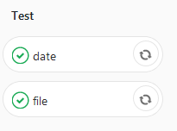

* Source: <https://gitlab.com/help/ci/yaml/README>
* Source for pipelines: <https://docs.gitlab.com/ee/ci/pipelines.html>

## Advanced file gitlab-ci.yml

|  |
| --- |
| before_script:  - echo "before_script instructions here"  stages:  - test  - build  - deploy  test:  stage: test  script: echo "Running tests"  build:  stage: build  script: echo "Building the app"  deploy_staging:  stage: deploy  script:  - echo "Deploy to staging server"  environment:  name: staging  url: https://staging.example.com  only:  - master  deploy_prod:  stage: deploy  script:  - echo "Deploy to production server"  environment:  name: production  url: https://example.com  when: manual  only:  - master |

* **script:** Chaque ligne représente des commandes à exécuter par le runner.
* **environment:** Défini les environnements spécifiques de déploiement des jobs (exemple: qa, review, staging, production, test, etc). Le nom des environnements est laissé libre au développeur
* **when:** Définir quand est ce que le job doit être lancé (manual, on_failure/on_success, always).
* **only:** Ne Déclencher le job que lors de push ou commit sur certaines branches ou tags.
* **except**: Ne pas déclencher le job lors de push ou commit sur certaines branches ou tags.
* Sources: <https://docs.gitlab.com/ee/ci/environments.html> <https://www.supinfo.com/articles/single/6822-integration-continue-gitlab-gitlab-ci-cd>

# Deploy in production

With pipelines we will understand the order to deploy our application in production:

1. Build the environment
2. Test the code
3. Create the Docker image and push into Gitlab registry
4. Deploy in production (not finish)

In this case, we will create a simple webserver Apache (httpd) with a web page in HTML. The goal is when we change the HTML page, the Docker container is update on the Gitlab registry.

## Build the environment

### File HTML

Create our registry on Gitlab, and create a “index.html” with content like:

|  |
| --- |
| <!doctype html>  <html lang="fr">  <head>  <meta charset="utf-8">  <title>Congratulation</title>  </head>  <body>  <center>  <h1>  Congratulation !  </h1>    <br/>    <h2>  If you see this page you have have succeed the CI/CD deployment.  </h2>    <br/><br/><br/>    <h4>  Proudly deploy with CI/CD pipelines on Gitlab  </h4>    </center>  </body>  </html> |

### File .gitlab-ci.yml

Create our first stage: build.

|  |
| --- |
| stages:  - build  build:  stage: build  image: httpd:latest  script:  - apachectl -t |

The pipeline will return OK.

## Test the code

### File .gitlab-ci.yml

This part need more explication…

|  |
| --- |
| stages:  - build  - test  - docker  build:  stage: build  image: httpd:latest  script:  - apachectl -t  test:  stage: test  image: httpd:latest  script: apachectl -t  coverage: /All files\s*\|\s*([\d\.]+)/ |

## Create the Docker image and push into Gitlab registry

### File docker-compose.yml

Docker-compose contain all the options you want to configure for your Docker image:

|  |
| --- |
| version: "2"  services:  app:  build:  context: .  dockerfile: Dockerfile  image: registry.gitlab.com/damiendeberthe/my-awesome-project  ports:  - "80:80" |

* Image: chose the registry where you will push the future Docker image (in this case, in the repository of the Gitlab project)

### File Dockerfile

The Dockerfile for your Docker container:

|  |
| --- |
| FROM httpd:latest  MAINTAINER DamienDeberthe  WORKDIR /usr/local/apache2/htdocs  COPY . .  # For security  RUN rm .gitlab-ci.yml Dockerfile docker-compose.yml README.md |

* “COPY . .” : copy the file in the repo Gitlab into the work directory /usr/local/apache2/htdocs .

### File .gitlab-ci.yml

|  |
| --- |
| stages:  - build  - test  - docker  build:  stage: build  image: httpd:latest  script:  - apachectl -t  test:  stage: test  image: httpd:latest  script: apachectl -t  coverage: /All files\s*\|\s*([\d\.]+)/  docker:  stage: docker  image: docker:latest  services:  - docker:dind  script:  - apk add --update py-pip && pip install docker-compose  - docker login -u gitlab-ci-token -p "xxx" "registry.gitlab.com"  - docker-compose build  - docker push "registry.gitlab.com/damiendeberthe/my-awesome-project" |

* The gitlab-ci-token is created in the menu: User Settings 🡪 Token 🡪 Select API, give a name and an expiration date.
* Docker push: select the same registry as you chose in the docker-compose.yml

You will see a new Docker image in your Gitlab registry.

## Deploy in production

### Manually

Connect your Docker server to your Gitlab account:

docker login registry.gitlab.com

#### Simple install

docker create -p 80:80 --name=my-awesome-project-web registry.gitlab.com/damiendeberthe/my-awesome-project:latest

docker start my-awesome-project-web

**OU**

docker run -d -p 80:80 --name=my-awesome-project-web registry.gitlab.com/damiendeberthe/my-awesome-project:latest

#### Update

|  |
| --- |
| docker stop my-awesome-project-web ;  docker rm my-awesome-project-web ;  docker rmi registry.gitlab.com/damiendeberthe/my-awesome-project:latest ;  docker create -p 80:80 --name=my-awesome-project-web registry.gitlab.com/damiendeberthe/my-awesome-project:latest \  && docker start my-awesome-project-web |

**OU**

|  |
| --- |
| docker stop my-awesome-project-web ;  docker rm my-awesome-project-web ;  docker rmi registry.gitlab.com/damiendeberthe/my-awesome-project:latest ;  docker run -d -p 80:80 --name=my-awesome-project-web registry.gitlab.com/damiendeberthe/my-awesome-project:latest |

* Source: <https://connect.adfab.fr/outils/gitlab-1-git-clone>

### Automatically with Rancher

First, it’s important to know that we use the **Rancher v.1.6**.

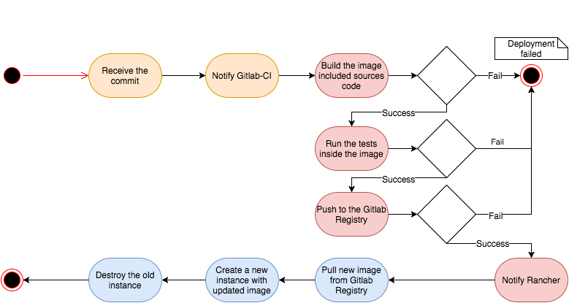

#### Variables environment

First if all, on Gitlab, we need to add variables for Rancher: “Paramètres” 🡪 “Intégration et livraison continues”

* **RANCHER_URL**: [<http://your-awesome-rancher.domain.com>](%3chttp://your-awesome-rancher.domain.com%3e)
  + The URL to access at your Rancher. If you use gitlab.com, you have to give access with a domain name on WAN network.
* **RANCHER_ACCESS_KEY**: <Access_Key>
  + On Rancher: In your environment 🡪 API 🡪 Keys 🡪 Add

Here is the “clef d’accès”

* **RANCHER_SECRET_KEY**: <Secret_key>

Here is the “clé secret” (mot de passe or password)

* **RANCHER_ENV**: <Environment_name>
* **RANCHER_STACK**: <Stack_name>
* **RANCHER_SERVICE**: <Service_name>

The *<Environment_name>*, *<Stack_name>* and *<Service_name>* need to exist before to continue.

#### Connection to registry Gitlab

We need to connect Rancher at our Gitlab account for pull the Docker container.

On Rancher, in our environment: “Infrastructure” 🡪 “Registry”:

* Adress: registry.gitlab.com
* User: <your_mail_on_Gitlab>
* Password: <your_pass_on_Gitlab>

#### File .gitlab-ci.yml with CDRX

|  |
| --- |
| stages:  - build  - test  - docker  - deploy  build:  stage: build  image: httpd:latest  script:  - apachectl -t  only:  - master  test:  stage: test  image: httpd:latest  script: apachectl -t  coverage: /All files\s*\|\s*([\d\.]+)/  only:  - master  docker:  stage: docker  image: docker:latest  services:  - docker:dind  script:  - apk add --update py-pip && pip install docker-compose  - docker login -u gitlab-ci-token -p "xxx" "registry.gitlab.com"  - docker-compose build  - docker push "registry.gitlab.com/damiendeberthe/my-awesome-project"  only:  - master  deploy:  stage: deploy  image: cdrx/rancher-gitlab-deploy  script:  - upgrade --environment $RANCHER_ENV --stack $RANCHER_STACK --service $RANCHER_SERVICE --start-before-stopping --no-wait-for-upgrade-to-finish  only:  - master  when: manual |

At the stage « deploy » we use the image cdrx/rancher-gitlab-deploy and we deploy automatically (with the option --start-before-stopping) our Docker container into Rancher.

Be careful! You need to manually execute the stage “deploy” in the pipeline.

Help: <https://github.com/cdrx/rancher-gitlab-deploy>

* Source: <https://anthonykgross.fr/p/deploiement-continu-docker-gitlab-rancher>

Need to test: <https://mikaoelitiana.name/fr/deployer-image-docker-rancher-gitlab/>